PARTS ORDERING AND RECEIVING GUIDE

*Using Mitchell 1 TeamWorks SE software*

Mitchell 1 is an inventory management software that you will primarily use when ordering and receiving parts. In this guide we will go over some of the basic software functions and how to properly use them

For the most part you will be using Mitchell for

* Navigating open ROs and ordering parts (repair orders)
* Creating and receiving parts on POs (purchase orders)
* Searching Inventory to check for parts in stock
* Completing stock orders
* Searching customer records

*Navigating WIP (work in progress)*

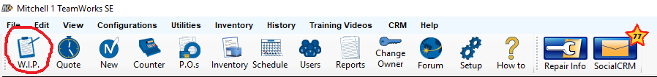

While Mitchell is open you can select the WIP tool in the top left of the program on the tool bar to open up a list of current customer ROs (repair orders) and INV (invoices). By double clicking any of the names located in WIP you can open that customer’s ticket

Example

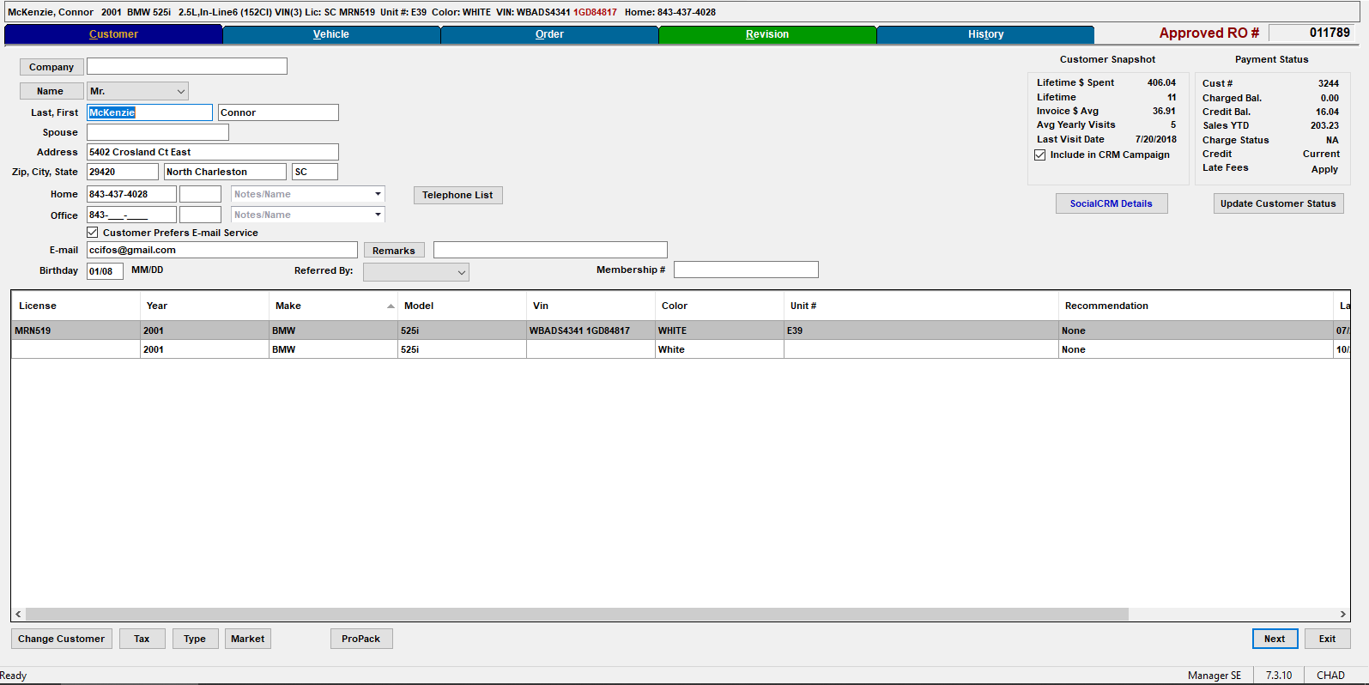 Here you can select which vehicle you would like to open a repair order for. After selecting a vehicle you see current parts and labor in the order tab, and estimates in the revision tab. Or look up vehicle history.

*Receiving Parts*

You can access purchase orders through the main toolbar at the top of Mitchell, or if the part was ordered for a customer you can access the PO through that customers Repair Order.

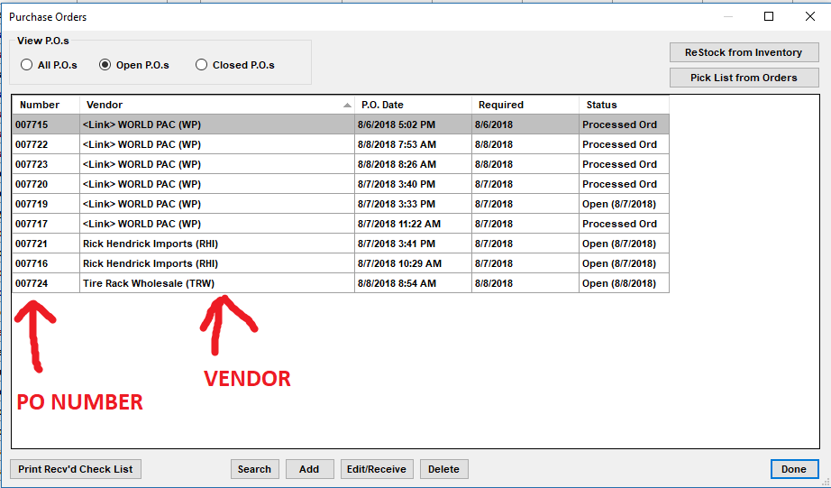

When a part comes in the invoice will have the vendor name along with a PO# use this information to find the correct PO to receive the part.

Once you have found the right PO and part number click [Receive] this will open another window asking you where you want to receive the part to. Because there is no RO number at the top of the PO this part gets received to inventory. Check the correct box hit ok and then close the PO.

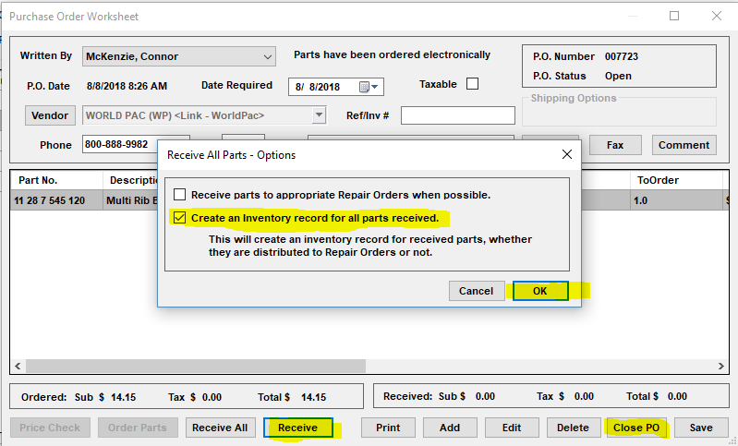

Parts ordered specifically for customers will have a RO # at the top of the PO, this is how you know whether to receive it to inventory or a repair order. Parts ordered for inventory will not have this number

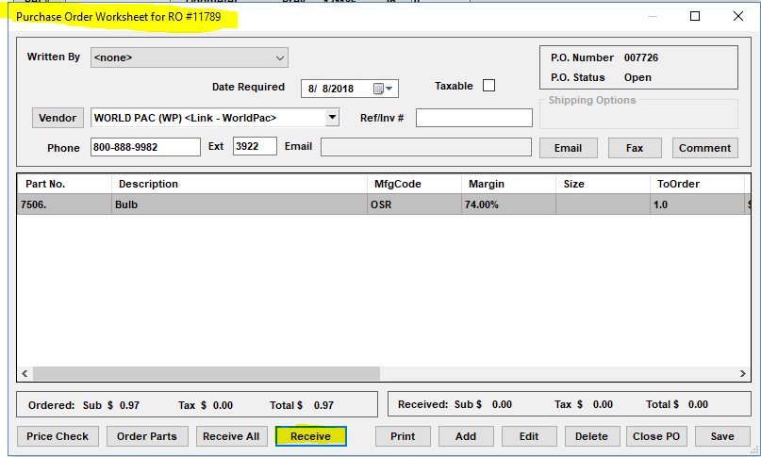

Click Receive and check the box for ‘receiving to appropriate ROs’ this will bring up another window with a customer’s name. Tag the name and hit OK to receive that part to the repair order. From there either hit close PO (if all parts are shown in green) or hit save if you are still waiting for parts to come in on the same order

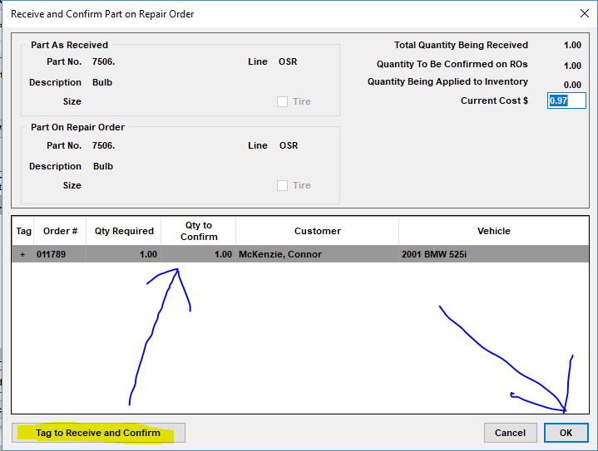

*Parts Ordering*

Whether parts are ordered for a customer or for stock they must be tied to a PO. When ordering parts for a customer take the following steps

Select customer from WIP list, then select customer vehicle and go to the order tab.

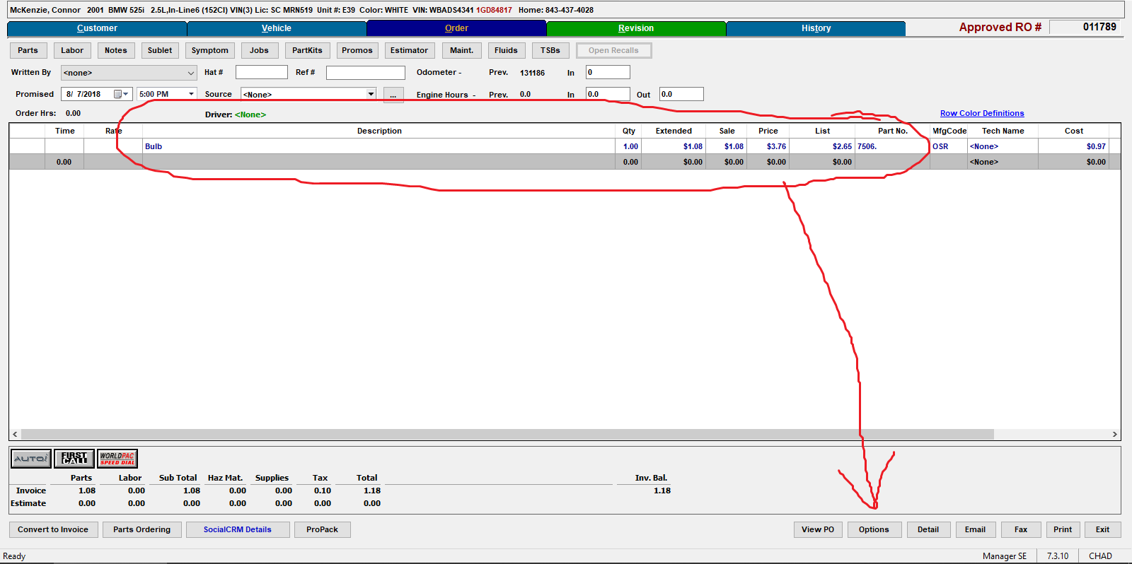

Once on the order tab go to [Options] this will open another smaller window from there select picklist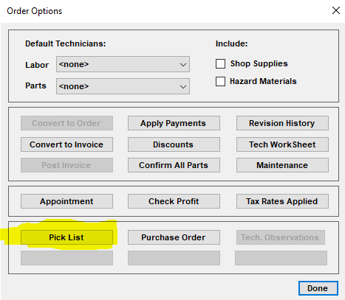

Cont next page

After you select picklist it will bring up another window containing all the parts on the repair order, tag a part or parts and select [Create Order]

(Tagged parts show a + sign next to quantities, make sure you hit show all parts at the top so you don’t miss any items.)

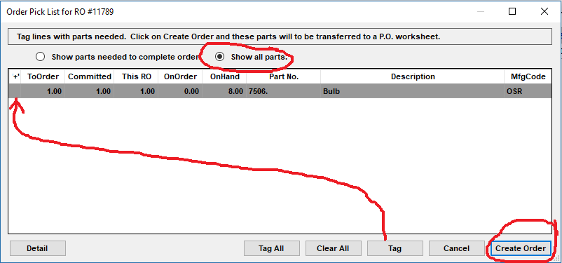

After you’ve created the PO make sure to select vendor [worldpac], for OEM parts you will want to use Rick Hendrick Imports.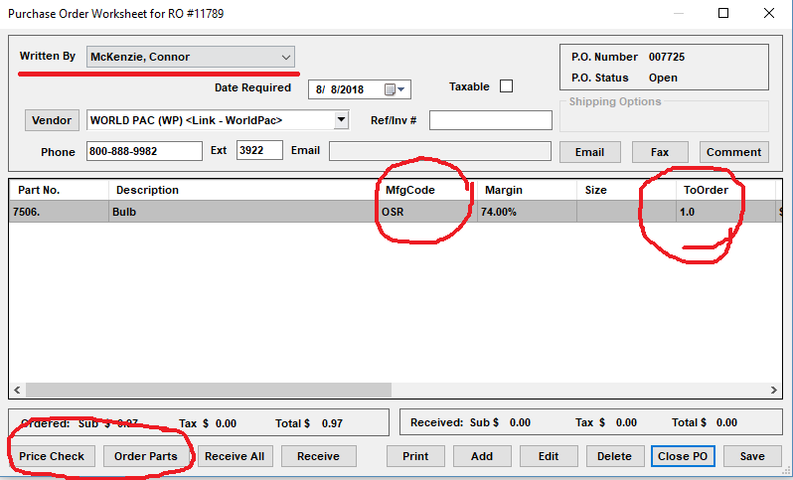

Once you’ve ensured that all the information in the PO is correct (quantity, current cost, brand) click on order parts down at the bottom. This will open up the catalog of whatever vendor you have selected.

From here just confirm everything looks correct and complete the checkout, it will tell you when the truck is leaving the warehouse. Orders from Columbia before 12:00pm arrive same day

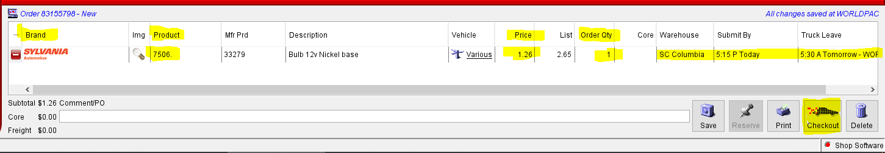

Ordering parts for inventory is going to be almost the same process but you can skip going through a repair order and go straight to POs and click [Add]

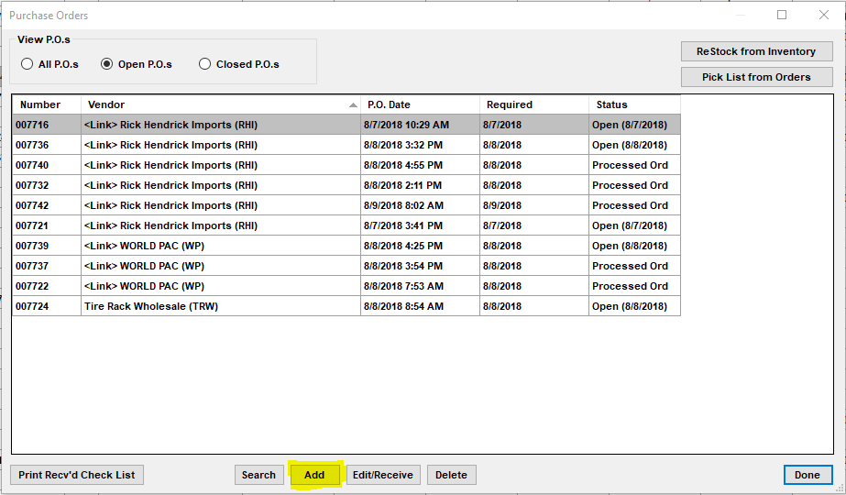

After opening up a new PO you can then start adding parts you want to order, you can do this by clicking [Add] again and either going through inventory, or typing in the part number.

